# [**All 3 Law & Order Casts Tease Premiere Crossover Event**](https://www.eonline.com/news/1347337/all-3-law-order-casts-tease-premiere-crossover-event?cmpid=social&medium=link-post&source=twitter-tv-scoop&content=organic)

## Hear what the *Law & Order*, *SVU* and *Organized Crime* cast members had to say ahead of the historic crossover event kicking off three new seasons in E! News’ exclusive preview.

**By** [**ALEX ROSS**](https://www.eonline.com/authors/alex-ross) **SEP 22, 2022 1:48 PMTAGS**

**Watch: Sam Waterson Thanks Fans For His Law & Order Return**

The action is never *dun dun* when it comes to the [***Law & Order***](https://www.eonline.com/news/law_and_order) franchise.

For the first time ever, the brand is kicking off its return to Thursday night TV with a massive crossover event, uniting the dedicated detectives from the [***Special Victims Unit***](https://www.eonline.com/news/law_and_order_special_victims_unit), [***Organized Crime***](https://www.eonline.com/news/1322843/find-out-which-law-order-svu-fan-favorite-is-headed-to-organized-crime) and [**the O.G. show**](https://www.eonline.com/news/1320647/why-the-return-of-law-order-felt-like-homecoming-for-the-o-g-stars) for a single case.

E! News caught up with cast members from across the *L&O* universe at their joint-premiere carpet in New York City to get the scoop on all the perp-busting, law-breaking and teamwork set to hit TVs in the all-encompassing, three-hour story. So what's the verdict?

"It's *lit*!" said **Danielle Monet Truitt**, who plays *Organized Crime* task force Sergeant Ayanna Bell. "And I'm going to say it's powerful and surprising."

Though *Organized Crime* typically wraps up the *L&O* programming in NBC's 10 p.m. time slot, Bell and her team will lead premiere night instead, followed by *SVU* at 9 p.m. and *Law and Order* at 10.

One delicate situation that will come to pass from the last season of *Organized Crime* involves the relationship between Sergeant Bell and her wife Denise (**Keren Dukes**), who fled their apartment and took the couple's baby son, Jack, with her.



[**PHOTOS**](https://www.eonline.com/photos/2145/law-order-great-guest-stars)

[**Stars Who Got Their Start on *Law & Order***](https://www.eonline.com/photos/2145/law-order-great-guest-stars)

Truitt said that moving forward, fans will see Bell struggling to adjust to her life as a single mom.

"I think in the beginning of the season, Bell is like, 'What are we doing? Why are we getting divorced?'" Truitt explained. "And then she has the rude awakening of realizing Denise is serious. Then Bell has to do some self-reflection and look at herself and say, 'Okay, where did I fail as a partner? How have I failed as a mother, and how can I be a better version of myself and be what Jack needs me to be?'"

NBC

She continued, "You're going to see Bell have to deal with some things within herself while also leading the squad. I feel like the mom of the group! Bell's character is the mama bear, even for Stabler [[**Christopher Meloni**](https://www.eonline.com/news/christopher_meloni)] because sometimes he runs off and she's got to keep him in line."

Meanwhile, *Organized Crime*'s resident computer genius Jet Slootmaekers ([**Ainsley Seiger**](https://www.eonline.com/news/1320819/meet-ainsley-seiger-law-order-organized-crimes-rising-star)) revealed that during season three, "Junior Year Jet" will really be "coming into her own" as the big kids on campus do.

"We're going to see a different side of Jet this season," Seiger shared. "For someone who famously always has the answers and is very good at doing her job in an efficient way, I'm excited to see her get to kind of grapple with the question of, 'Who are you if you're the person who maybe doesn't have the answer? Who do you become, when that's your whole personality? What does that force you to reckon with in your personal life?'"



[**PHOTOS**](https://www.eonline.com/photos/17084/mariska-hargitay-s-law-and-order-svu-hair-through-the-years)

[**Mariska Hargitay's *Law and Order: SVU* Hair Through the Years**](https://www.eonline.com/photos/17084/mariska-hargitay-s-law-and-order-svu-hair-through-the-years)

[by Taboola](https://popup.taboola.com/en/?template=colorbox&utm_source=eonline-eonline&utm_medium=referral&utm_content=rec-reel-2n5-b:Mid%20Article%20Thumbnail:)

[Promoted Links](https://popup.taboola.com/en/?template=colorbox&utm_source=eonline-eonline&utm_medium=referral&utm_content=rec-reel-2n5-b:Mid%20Article%20Thumbnail:)

[**E! NewsKylie Jenner Shows Off Major Underboob in Risqué Outfit**](https://www.eonline.com/news/1347104/kylie-jenner-shows-off-major-underboob-in-risque-outfit?cmpid=enewsarticle&source=taboola&medium=Mid%20Article%20Thumbnail)

[**Cleverst40 Dated Décor Trends That Scream 'Senior'**](https://rfvtgb.cleverst.com/worldwide/homdec-ta?utm_medium=taboola&utm_source=taboola&utm_campaign=ta-cl-homdec-bc2-des-0w-mm-16092a&utm_term=eonline-eonline&utm_bid=Hej4NfK5T8PIEEFEfMto8AcXFtDyNVuTcJBwWyb8_Os=&utmk=GiDWb98FVCiuFj8uWFSLtfawL9mq5X93ih7omFYETVL-FSD10Uoo0rPW_IqtvMLlAQ)

[**E! NewsHas Tom Bergeron Retired from Hosting? He Says...**](https://www.eonline.com/news/1347487/has-tom-bergeron-retired-from-hosting-he-says?cmpid=enewsarticle&source=taboola&medium=Mid%20Article%20Thumbnail)

[**E! NewsBrad Pitt Credits Ex-Fiancée and "Dear Friend" Gwyneth Paltrow for This Personal Milestone**](https://www.eonline.com/news/1347281/brad-pitt-credits-ex-fiancee-and-dear-friend-gwyneth-paltrow-for-this-personal-milestone?cmpid=enewsarticle&source=taboola&medium=Mid%20Article%20Thumbnail)

[**Siemens EnergyLower diesel consumption in shipping**](https://ad.doubleclick.net/ddm/trackclk/N1355190.2621703TABOOLAEUROPELTD/B26996758.323952167;dc_trk_aid=534811748;dc_trk_cid=175812337;dc_lat=;dc_rdid=;tag_for_child_directed_treatment=;tfua=;ltd=?tblci=GiDWb98FVCiuFj8uWFSLtfawL9mq5X93ih7omFYETVL-FSC68FUoocqfv8Weh4Y4#tblciGiDWb98FVCiuFj8uWFSLtfawL9mq5X93ih7omFYETVL-FSC68FUoocqfv8Weh4Y4)

Last time E! spoke with Seiger, she was also busy manifesting future scenes between Jet and *SVU* Captain Olivia Benson ([**Mariska Hargitay**](https://www.eonline.com/news/mariska_hargitay)). Ask and you shall receive.

"We are going to get some more Jet and Olivia Benson content!" Seiger confirmed. "And I am always pushing for more. I love Mariska so much. In the crossover, there's so much overlap in between. Everyone is in a million different places at once, and it's so exciting."

One of Benson's direct reports is Detective Joe Velasco ([**Octavio Pisano**](https://www.eonline.com/news/1329909/law-order-svus-octavio-pisano-spills-on-end-of-season-surprises)), who fans will continue to see working on *SVU* Thursday. Pisano said shooting the crossover was "insane," telling E!, "We usually don't go that long shooting an episode. Luckily, we have great people in command, and they made everything so simple. But the most exciting part for me is the action sequences. I don't know if I can talk about it because it's a big surprise. It's going to be great."

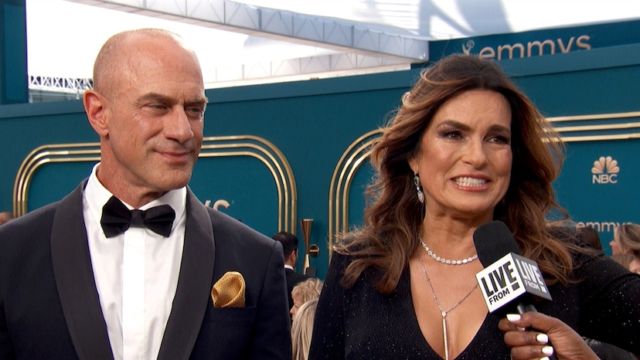

**Watch: Will SVU's Olivia & Elliot Ever Get Together? Mariska & Christopher Say...**

Rounding out the night's trio of female-led squads is Lieutenant Kate Dixon ([**Camryn Manheim**](https://www.eonline.com/videos/335240/camryn-manheim-calls-law-order-reboot-a-full-circle-moment)) on *Law & Order*, who called the premiere "brutal, shocking, and intercontinental," noting that the event is something she's "never seen done before in my lifetime."

"To be the first to present this epic three-part crossover feels really special," Manheim shared. "And I think all eyes are on us, which is good and bad—we want everyone to come and watch, but also, it's a lot of pressure. We want to make sure that we made it worth their while to spend the whole night with us."

The *Law & Order* crossover event premieres Thursday, Sept. 22, at 8 p.m. on NBC.

(E! and NBC are both part of the NBCUniversal family.)